

Using Conditions in Manifest
DevOps Certification Training

support@intellipaat.com
+91-7022374614
US: 1-800-216-8930(Toll Free)

USING CONDITIONS IN MANIFESTS
ONLYIF
Steps for Puppet Master

Step 1: Change the directory to /etc/puppet/code/environments/production/manifests
$ cd /etc/puppet/code/environments/production/manifests
$ sudo nano site.pp

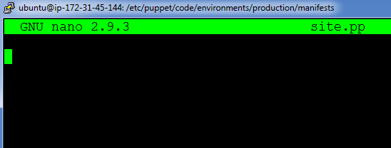

Step 2: Enter the following text:
node default{
exec{'Conditions':
command=> '/bin/echo "Apache is installed" > /tmp/software.txt',
onlyif=> '/bin/which apache2',
}
}

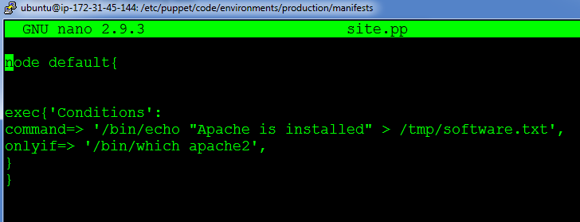

On Puppet Agent
Step 1: Execute the following command:
$ sudo puppet agent --test

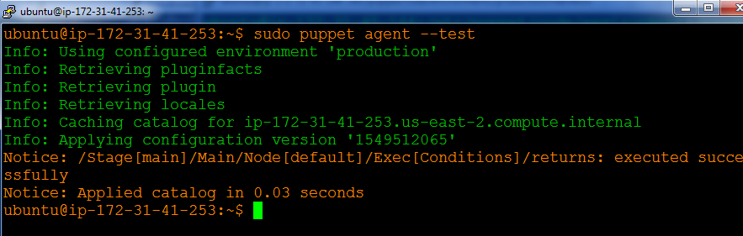

Step 2: Verify the file by going to /tmp/software.txt
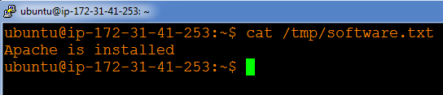

UNLESS
Steps for Puppet Master
Step 1: Change the directory to /etc/puppet/code/environments/production/manifests
$ cd /etc/puppet/code/environments/production/manifests
$ sudo nano site.pp



Step 2: Enter the following text:
node default{
exec{'Conditions':
command=> '/bin/echo "php is not installed" > /tmp/software.txt',
unless=> '/bin/which php,
}
}

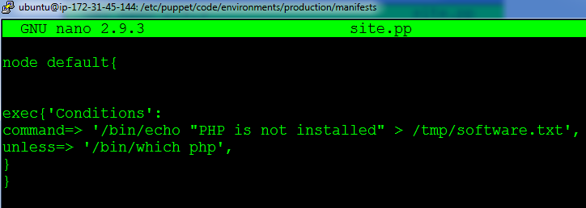

Steps for Puppet Agent

Step 1: Execute the following command:
$ sudo puppet agent --test

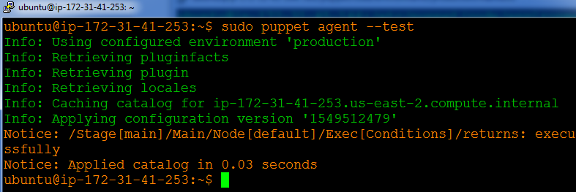

Step 2: Verify the file by going to /tmp/software.txt
